On the line
1.
It aint no crime 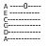to fell alive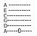Don’t pusch me downDon’t waste my time
Im born that way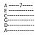Im born that way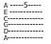Im born that way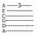
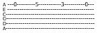
Dont waste my time!

2.
You told me tostay on the lineDon’t ever arskJust do it fine
Im not at childIm not at childIm not a childIm not at child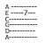
Dont waste my time!

3.
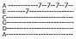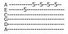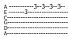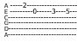
I make my own way , What ever you say , I don’t give at dam , Cuse its my life

4.
You think you are good, But I saw the news, Discowerd a way, far from your line

5.
It aint no crime to fell aliveDon’t pusch me downDon’t waste my time
Im born that wayIm born that wayIm born that way
Dont waste my time!

6.
You told me tostay on the lineDon’t ever arskJust do it fine
Im not at childIm not at childIm not a childIm not at child
Dont waste my time!

7.
I final can see , the end of your line , Your power has gone, and naw its mine!!!
Naw its mine
Naw its mine!!

